
PT1/PHAK/1222/A 16-MAY-2022
PERIODIC TEST 1 (2022-23)

Subject: PHYSICS (ANSWER KEY)  Grade: XII |  | Max. Marks:35  Time:
 | SECTION A
 | MCQ (1mark each)
The focal length of an equiconvex lens is equal to the radius of curvature of either face. The refractive index of the material of the lens is:
a)3/2
b)2/3
c)1/3
d)√3/2
2. | For the same angle of incidence, the angle of refraction in three different media A, B and C are 15 º, 25 º and 35 º . In which medium, will the velocity light be minimum?  a) A  b) B  c) C  d)velocity is equal in all mediums.
3. | A prism is made of glass of unknown refractive index. A parallel beam of light is incident on a face of the prism. The angle of minimum deviation is measured to be 30°.The refractive index of the material of the prism is: (The refracting angle of the prism is 60°)  a)2  b)1/2  c)√2  d)1/√2
4.
  Suppose that the lower half of the concave mirror’s reflecting surface is covered with an opaque (non-reflective) material. Then:
  a) image distance increases
  b) image distance decreases
  c) image intensity decreases
  d) image intensity increases
5. | Which of the following statement is not true?  - Optical fibres is based on the principle of total internal reflection.  - The refractive index of the material of the core is less than that of the cladding.  - an optical fibre can be used to act as an optical pipe.  d)There is no appreciable loss in the intensity of the light signal while propagating through an optical fibre
 | SECTION B
6. | ANS: Refractive index is inversely proportional to the wavelength of the light. Red has a higher wavelength than violet light therefore it has a smaller refractive index than violet.  Again, angle of minimum deviation is directly proportional to refractive index and hence will decrease when replaced by red light.
7. | 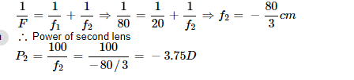
8. | Ans: 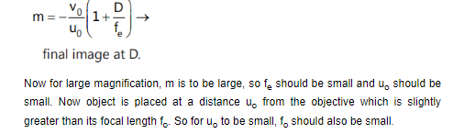
9. | Ans: Diagram (1/2mark)  Derivation (1.5marks)
10. | 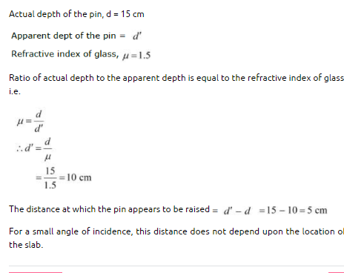
 | SECTION C (3marks)
11.
  ANS: Light should travel from a denser medium to a rarer medium,
  • Angle of incidence in denser medium should be greater than the critical angle for the pair of media in contact. (1mark)
  Derivation(2marks)
12. | With the help of a proper labelled diagram, derive an expression for refraction at a spherical surface if the ray of light is travelling from rarer to denser medium.  Derivation :3 marks
13. | Ans: 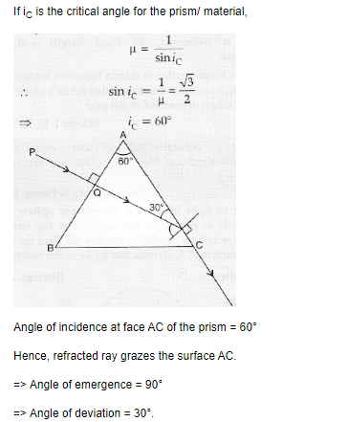
14. | ANS:  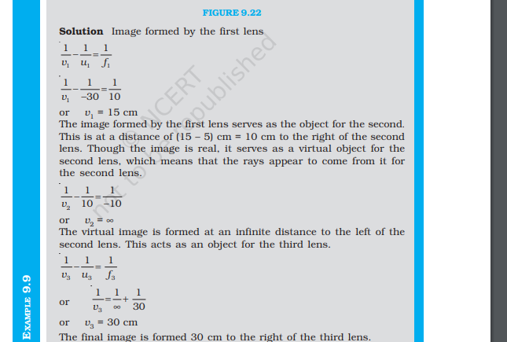
15. | 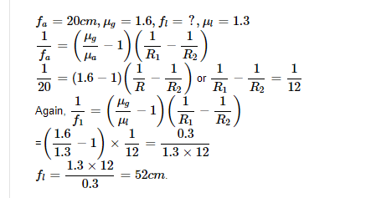
 | SECTION D(5marks)
16. | ANS: a) Diagram (1mark)  Derivation (2mrks)  b) 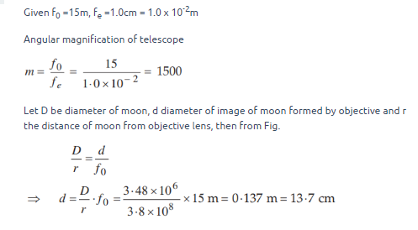 (2mrks)
**

